|  |
| --- |
| Serial No: |
| **Final Term Exam**  **Spring Semester 2020** |
| **Max Time: 3 Hour** |
| **Max Marks: 60** |
|  |

|  |
| --- |
| **CS302-Design and Analysis of Algorithm (Answer Sheet)** |
| Saturday, July 4, 2020 |
| **Course Instructor** |
| Mr. Adeel Ashraf Cheema  Mr. Muhammad Haris  Mr. Shoaib Saleem |

|  |
| --- |
| Roll No: 18F-0128 Name: Hassan Ashas Section: D |

**General Instructions:**

1. There are Six (6) Questions in total.
2. Questions reading and understanding are also part of the exam, only answer what is asked.
3. Read the questions carefully for clarity of context and understanding of meaning and make assumptions wherever required, **for neither the invigilator will address your queries, nor the teacher/examiner will respond to any of your queries.**

**Guidelines for Submission:**

1. You must solve/attempt it on **A-4 white paper** in your **own handwriting** and take the **picture of that solution** and insert it in provided answer sheet docx file. The image can be pasted inside that document under the appropriate question.
2. You should submit only one **PDF answer sheet file** Containing All Six(6) questions answers images.
3. Naming Convention of file must be followed.
4. Example:
   1. Rollnumber_Section.pdf
   2. **18f0123_C.pdf**
5. You must submit your answer sheet before due time in Assignment Section through **LMS** **(Slate** [**http://203.124.42.218:8080/portal**](http://203.124.42.218:8080/portal) **),** and also to be **emailed** to your class teacher within the deadline.
6. Use your **university provided email** for email purpose.
7. Subject of email must be **“Algo Final Exam Files”**
8. The email addresses of class teachers are
   1. adeel.cheema@nu.edu.pk Section- BCS-8A and BCS-4A
   2. m.haris@nu.edu.pk Section- BCS-4B
   3. shoaib.saleem@nu.edu.pk Section- BCS-4C and BCS-4D
9. *Slate and Email submissions submitted after the due time shall not be considered.*
10. If you don’t finish every part of a question, don’t worry! You can still submit what you’ve done to get marks based on your efforts.
11. **In case of copied or plagiarized solutions in exam Or If a student provided help to another student during exam both will be awarded "F" grade and it will affect the student CGPA.**
12. Viva of any student can be conducted by the instructor after conducting an online exam in case of any doubt.

**Guidelines for attempting:**

1. Your answer sheet (Every Image File) must contain your Full name, Roll number and Section and Cleary written in top of the page and must be in readable form.
2. Handwriting must be readable.
3. Proper explain the steps.
4. **Answer without steps or explanation (Direct Calculated answer) will get ZERO marks.**

|  |  |  |  |  |  |  |  |
| --- | --- | --- | --- | --- | --- | --- | --- |
|  | **Q-1** | **Q-2** | **Q-3** | **Q-4** | **Q-5** | **Q-6** | **Total** |
| **Total**  **Marks** | **10** | **10** | **10** | **10** | **10** | **10** | **60** |
| **Marks Obtained** |  |  |  |  |  |  |  |

|  |
| --- |
| **Question 1: Solution: Upload Images of your work here Marks = 2+2+6 = 10**  **Answer without steps or explanation (Direct Calculated answer) will get ZERO marks.** |

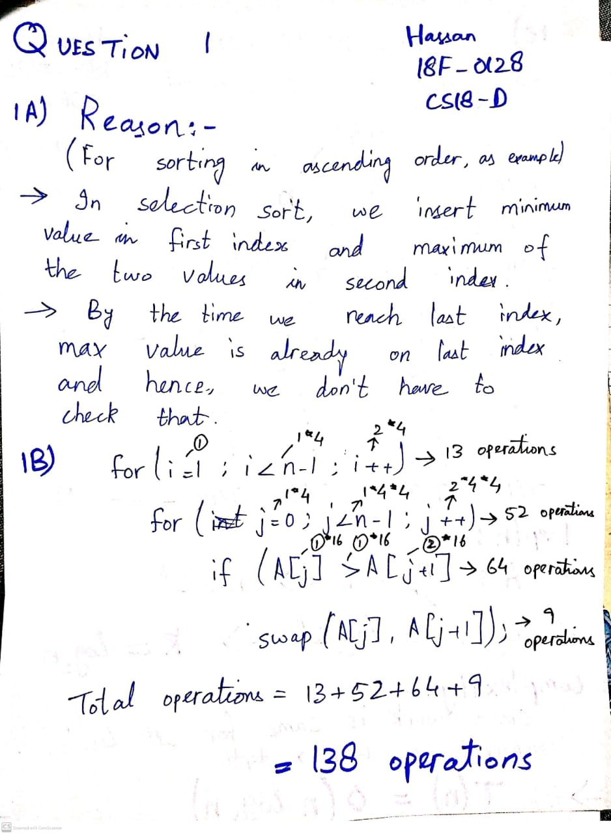

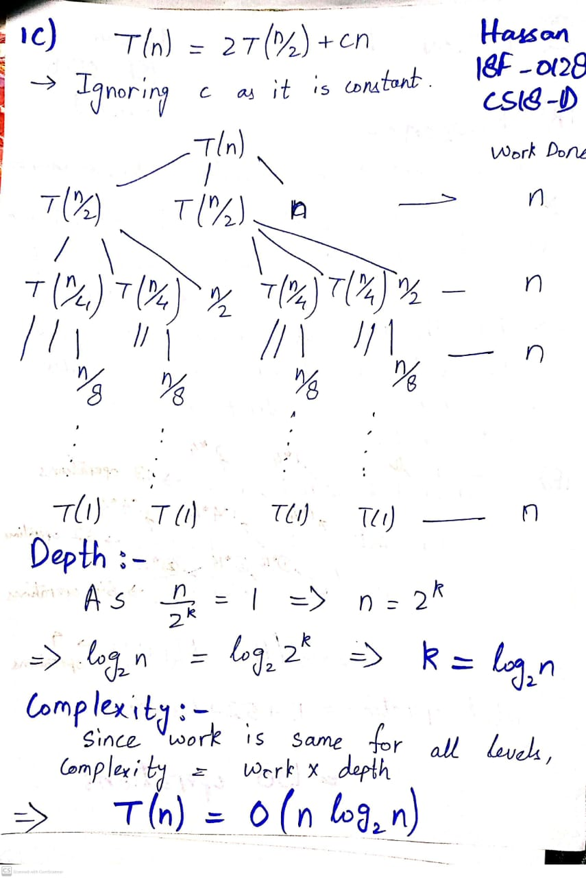

|  |
| --- |
| **Question 2: Solution: Upload Images of your work here Marks = 10**  **Answer without steps or explanation (Direct Calculated answer) will get ZERO marks.** |

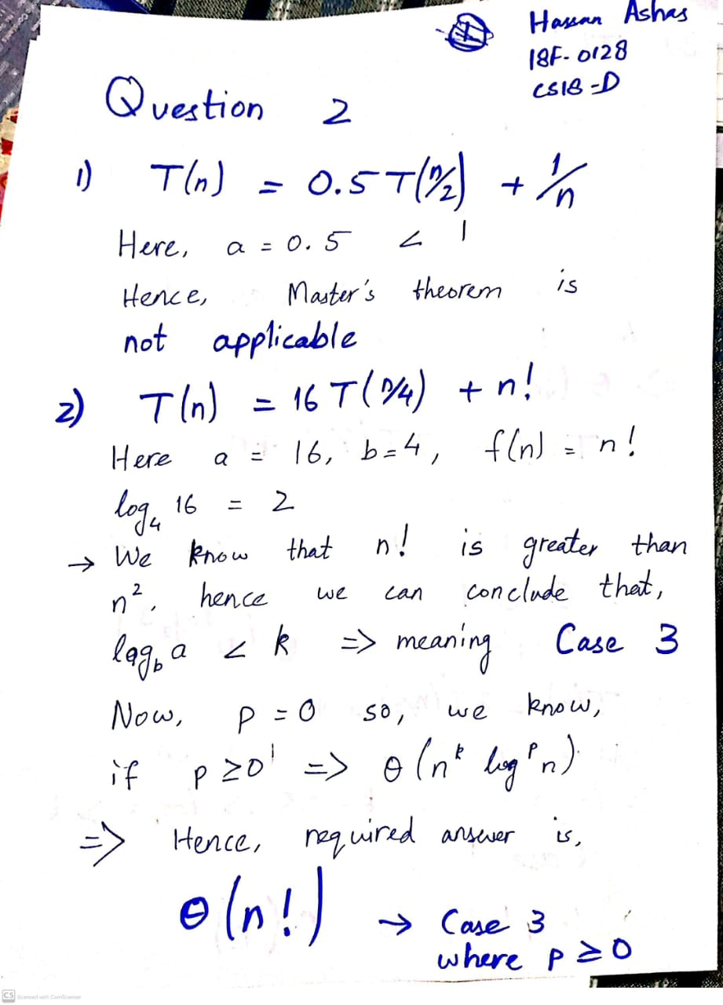

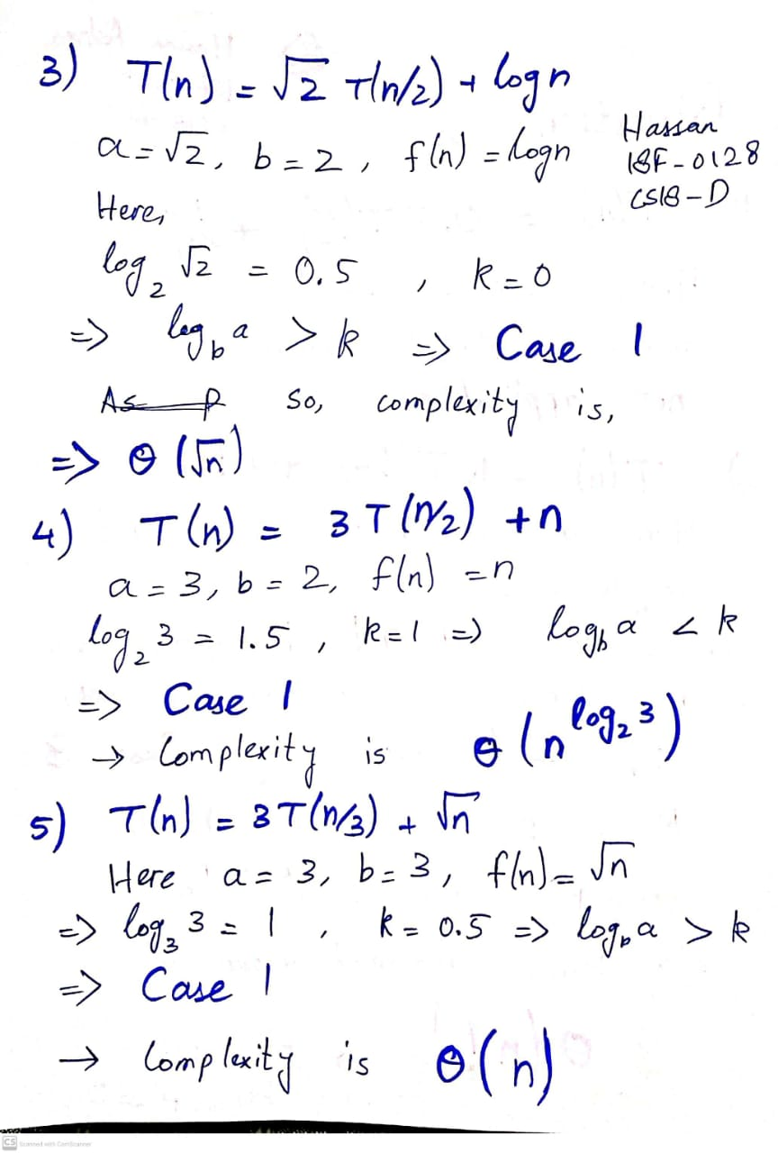

|  |
| --- |
| **Question 3: Solution: Upload Images of your work here Marks = 10**  **Answer without steps or explanation (Direct Calculated answer) will get ZERO marks.** |

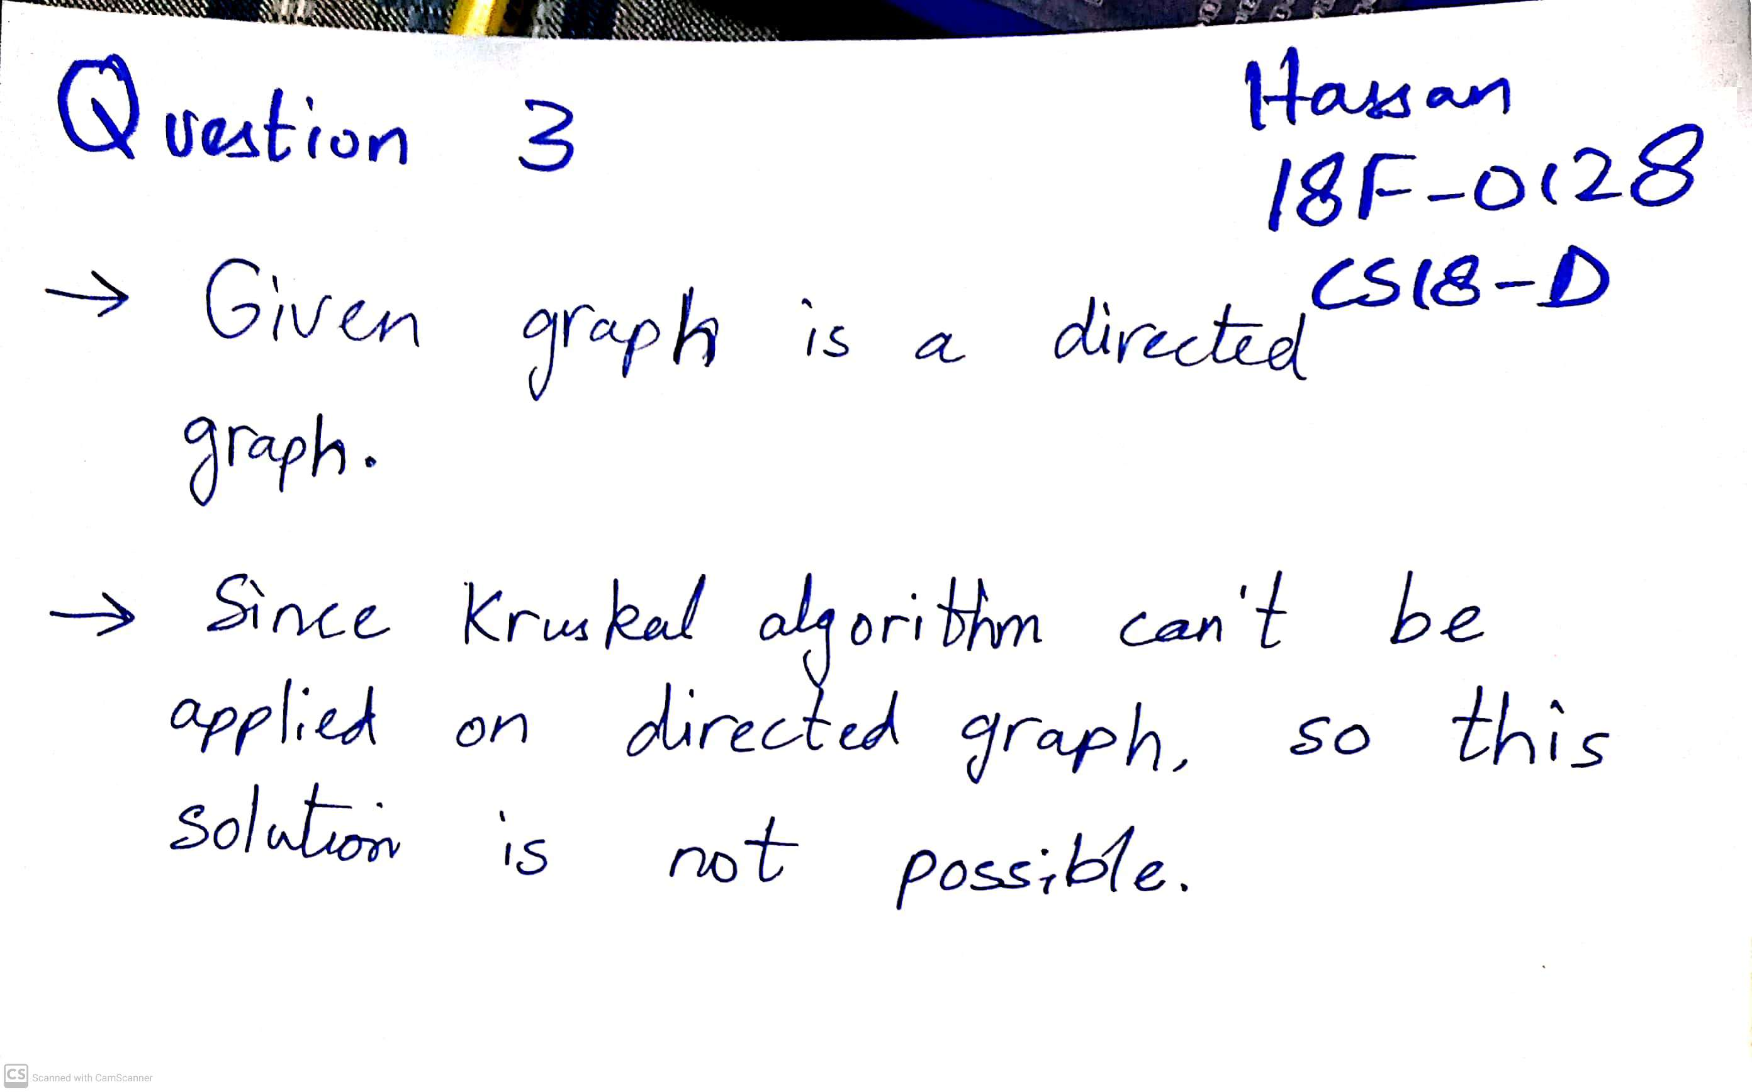

|  |
| --- |
| **Question 4: Solution: Upload Images of your work here Marks = 10**  **Answer without steps or explanation (Direct Calculated answer) will get ZERO marks.** |

|  |
| --- |
| **Question 5: Solution: Upload Images of your work here Marks = 10**  **Answer without steps or explanation (Direct Calculated answer) will get ZERO marks.** |

|  |
| --- |
| **Question 6: Solution: Upload Images of your work here Marks = 10**  **Answer without steps or explanation (Direct Calculated answer) will get ZERO marks.** |

